**Day 5 SQL Bootcamp Assignment**

**1. GROUP BY with WHERE - Orders by Year and Quarter**

**Display, order year, quarter, order count, avg freight cost only for those orders where freight cost > 100**

**Query:**

**SELECT**

**YEAR(order_date) AS order_year,**

**QUARTER(order_date) AS order_quarter,**

**COUNT(order_id) AS order_count,**

**AVG(freight) AS avg_freight_cost**

**FROM**

**orders**

**WHERE**

**freight > 100**

**GROUP BY**

**YEAR(order_date), QUARTER(order_date);**

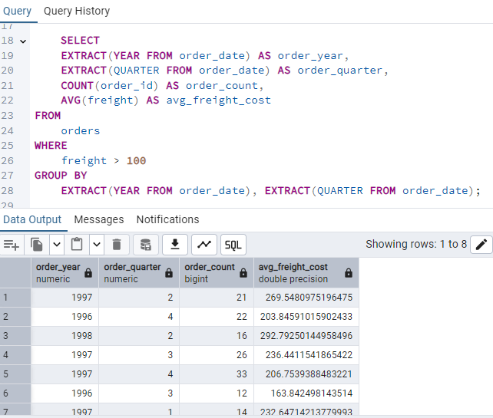

**2.GROUP BY with HAVING - High Volume Ship Regions**

**Display, ship region, no of orders in each region, min and max freight cost**

**Filter regions where no of orders >= 5**

**Query:**

**SELECT**

**ship_region,**

**COUNT(order_id) AS no_of_orders,**

**MIN(freight) AS min_freight_cost,**

**MAX(freight) AS max_freight_cost**

**FROM**

**orders**

**GROUP BY**

**ship_region**

**HAVING**

**COUNT(order_id) >= 5;**

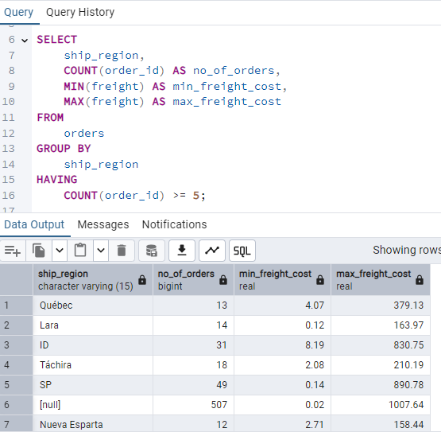

**3.Get all title designations across employees and customers ( Try UNION & UNION ALL)**

**Query:**

**SELECT title AS designation FROM employees**

**UNION**

**SELECT contact_title AS designation FROM customers;**

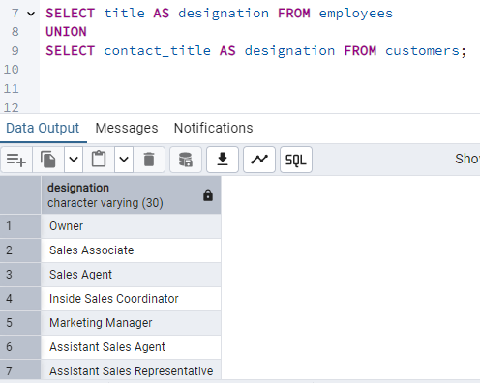

**Query:**

**SELECT title AS designation FROM employees**

**UNION All**

**SELECT contact_title AS designation FROM customers;**

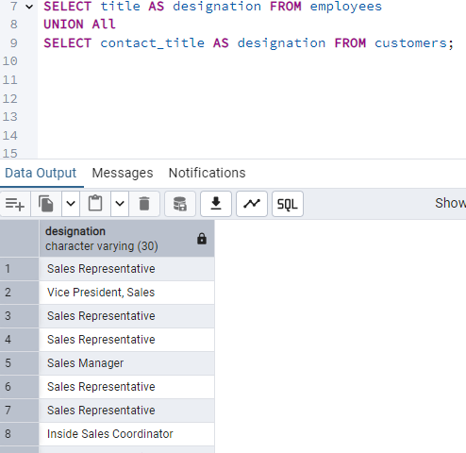

**4.Find categories that have both discontinued and in-stock products**

**(Display category_id, instock means units_in_stock > 0, Intersect)**

**Query:**

**SELECT category_id**

**FROM products**

**WHERE discontinued = 1**

**INTERSECT**

**SELECT category_id**

**FROM products**

**WHERE units_in_stock > 0;**

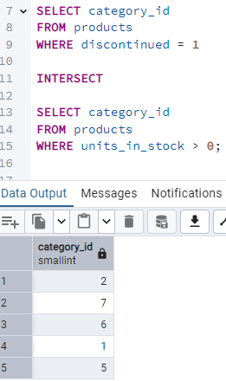

**5. Find orders that have no discounted items (Display the order_id, EXCEPT)**

**Query:**

**SELECT order_id**

**FROM order_details**

**EXCEPT**

**SELECT order_id**

**FROM order_details**

**WHERE discount > 0;**

